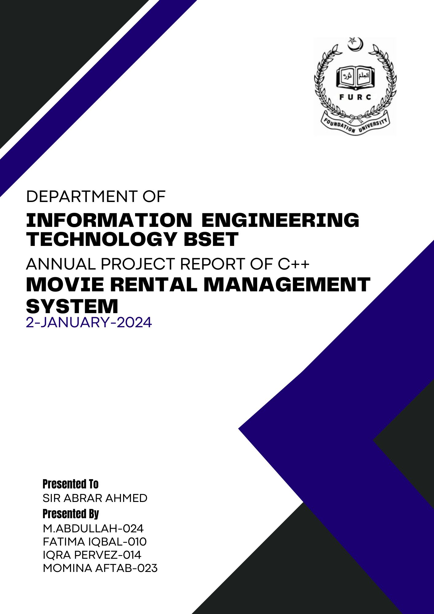

Contents

1. OVERVIEW OF PROJECT:- 3

2. FEATURES OF THE SYSTEM:- 3

3. OBJECTIVE OF THE SYSTEM:- 3

4. OVERVIEW OF UI:- 4

5. MOVIE RENTAL MANAGMENT SYSTEM USING C++ SOURCE CODE:- 5

6. NOW LET US UNDERSTANT THE CODE:- 6

7. FINAL OUTPUT:- 6

8. CONCLUSION:- 6

## OVERVIEW OF PROJECT:-

Cinema Booking System using C++ (With Source Code ).

**Hello, coders**. Welcome to the code with random blog. In this article, we will learn how to create a MOVIE RENTAL MANAGEMENT SYSTEM like a Cinema Booking System using C++ (With Source Code ).

A MOVIE RENTAL MANAGEMNT SYSTEM is a console based software which provides a basic interface with options for movie selection, ticket booking, membership card registration, and contact information. This system is an online platform which allows users to reserve and purchase movie tickets for a theatre or Cinema.

# FEATURES OF THE SYSTEM:-

* **Efficient Ticket Booking:**

Develop a user-friendly interface for customers to easily browse movie schedules, select seats, and book tickets online or at the cinema.

* **Seat Management:**

Implement a system to manage and allocate seats dynamically, ensuring optimal occupancy for each screening.

* **Movie Scheduling:**

Provide an intuitive interface for cinema administrators to create and manage movie schedules, including details such as show times, screening rooms, and pricing.

* **Employee Management:**

Incorporate tools for cinema staff management, including roles such as ticket sellers, ushers, and managers, with features like attendance tracking and performance monitoring.

* **Reporting and Analytics:**

Integrate a reporting system that provides insights into ticket sales, popular movies, peak hours, and other relevant data to assist in decision-making.

# OBJECTIVE OF THE SYSTEM:-

The Movie Cinema Management System includes the following key features:

* **User Registration and Authentication:**

Customers can create accounts, log in securely, and manage their profiles for a personalized experience.

* **Movie and Schedule Management:**

Cinema administrators can add, edit, or remove movies, specify screening times, and allocate screening rooms.

* **Seat Selection:**

Customers can view the layout of the cinema hall and select their preferred seats during the booking process.

* **Online Booking:**

Facilitate online ticket booking, allowing customers to purchase tickets conveniently through the cinema's website or mobile app.

* **Employee Dashboard:**

Provide cinema staff with a dashboard for managing tasks, monitoring attendance, and accessing relevant information.

* **Reporting Tools:**

Generate reports on ticket sales, attendance, and other key metrics to aid in decision-making and strategic planning.

# OVERVIEW OF UI:-

———————————-

BOX OFFICE

———————————-

Welcome Customer!

<1> Movie Timings

<2> Contact Us

<3> DTCard Registration

<4> Exit

Enter Your Choice :”

The user will choose an option to perform the operation of their choice. User will then enter a values according to the prompts that will be displayed on the console to perform that operation.

# MOVIE RENTAL MANAGMENT SYSTEM USING C++ SOURCE CODE:-

# NOW LET US UNDERSTANT THE CODE:-

# FINAL OUTPUT:-

# CONCLUSION:-

The Movie Cinema Management System is a powerful and scalable solution designed to meet the operational needs of modern cinemas. By automating key processes, enhancing the customer experience, and providing valuable insights through reporting tools, the system aims to contribute to the success and growth of cinema businesses.

This project report outlines the objectives, features, and technology stack, showcasing the potential of the Movie Cinema Management System to revolutionize the cinema industry by embracing digital transformation and improving overall operational efficiency.

Future Enhancements while the current version of the Movie Cinema Management System fulfills its core objectives, there are opportunities for future enhancements. These may include the integration of additional features such as loyalty programs, targeted marketing tools, and real-time analytics for better decision-making. The system could also explore partnerships with online platforms for broader reach and accessibility.

The success of the Movie Cinema Management System hinges not only on its technical capabilities but also on its ability to adapt to the evolving needs of the cinema industry. Ongoing collaboration with stakeholders, continuous improvement through feedback, and a commitment to innovation will be crucial in maximizing the system's positive influence on the cinema business landscape.